
Strategic Needs and Strengths Assessment

Bail Support & Supervision
Template for Completion by
Community Justice Partnerships

[insert publication date here]
About this Template
Strategic needs and strengths assessment (SNSA) is the foundation on which an area can understand the needs of their population and the services and interventions that are in place locally. SNSA will facilitate evidence-led planning to effectively address the needs of individuals in a local area. A full SNSA should provide a comprehensive overview of community justice in that locality and the needs, issues and strengths specific to that area. Guidance supporting the production of a full SNSA was issued by CJS in February 2020.
In March 2020 the COVID-19 pandemic struck and had, and continues to have, a significant impact on every part of life including the justice system. Community justice-based agencies have toiled to maintain delivery of essential services against a backdrop of changing priorities and varying degrees of intermittent lockdowns. Throughout the period of the pandemic people and partners have sought innovative and creative ways to support the most vulnerable in our communities and sustain critical activity around public protection whilst recognising that workers are also struggling with health, care and self-isolation issues.
The impact of this on activities such as strategic planning has been considerable, particularly on key tasks such as the development of local SNSAs and Community Justice Outcome Improvement Plans (CJOIPs). Following a meeting with the Community Justice Network in September 2020, and three CJS-led briefing sessions with CJP chairs, it was agreed that providing some guidance as to how strategic planning for community justice might be best approached during lockdown and into recovery would be of some benefit.
The CJS (and legislative) position is that every area should have an up-to-date CJOIP, populated through the process outlined in the SNSA guidance. Where this is not possible, CJS have set out a minimum expectation that local areas focus on three specific areas of activity to produce targeted SNSA reports:
- Arrest Referral | - Diversion | - Bail Support and Supervision

This template builds on the SNSA guidance and provides more detail about how to produce a targeted SNSA report in respect of Bail Support and Supervision. The template contains an overview of Bail Support and Supervision, nationally, including key principles and key roles. National and local data sources which will help to develop demographic, need and service profiles are outlined and examples are included of how data might be presented using narrative and visual descriptions. Guidance is included in how to approach horizon scanning, the analysis of the data and the development of recommendations and priorities.
The national data within this template can be used by every area in Scotland but it is essential that it is supplemented with local data and information. Only by doing this will CJPs understand the local needs of their population and the services and interventions that are in place locally. Guidance on the methods and considerations for collating local data and information are signified throughout this template by a signpost icon.
The primary purpose of this template is to assist CJPs to begin to, where they have not previously, engage in a measured and supported way with the SNSA process as a means of creating, revising or developing their local CJOIP. The completion of targeted SNSA reports will begin the process towards a full SNSA and will provide assurance to CJPs (and to CJS when local areas, as is legally required, consult with us about new CJOIPs) that local outcomes and priorities are robustly evidence-based.
Strategic Needs and Strengths Assessment
Template for Local Area Completion

Local Authority Area:

Focus on: BAIL SUPPORT & SUPERVISION

Overview | What is bail supervision?  Bail Supervision is a social work or third sector activity designed to support people on bail to adhere to the standard conditions of bail who are at increased risk of remand and/or non-compliance. In such cases, people are released on bail on the condition that they meet with a bail supervisor a specified number of times a week; the aim of these meetings being to support the individual to comply with the conditions of their bail. The term “bail supervision” is not a legislative creation: rather a further condition of standard bail that an individual is placed under supervision for a period of bail in the community.  The national bail supervision guidance sets out the operation of bail supervision services by local authority criminal justice social work and other agencies involved in service delivery that compliments local CJOIPs.  The aim of Bail Supervision can be outlined as follows:  - Bail supervision is intended to provide a robust and credible alternative to remand where individuals are assessed as needing a level of supervision and support to ensure they comply with the bail order and any additional conditions of bail.  - Bail supervision is an additional condition of bail. The use of bail reduces the number of people held in custody pending trial who, subject to safeguards in respect of public protection, could be released on bail to the community pending their further court hearing.  - Providing bail supervision services tailored to the needs of the individual and the community can ensure that remand is only used where necessary.  The benefits of a successful bail supervision are:  - Individuals who may have been at risk of remand are supported to remain in the community.  - Individuals have access to community based services which may not be available within the prison environment.  The Scottish Justice Map  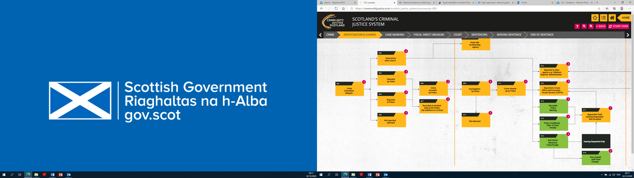  Bail Supervision is an alternative to remand and sits within the “Investigation & Charge” section of Scotland’s justice system.  The following flowchart sets out the steps towards the Bail Supervision process. Bail Supervision and the specifics of its delivery will differ from area to area, and so the formation of a local flowchart/process map will be required to fully understand how this process operates within your area.  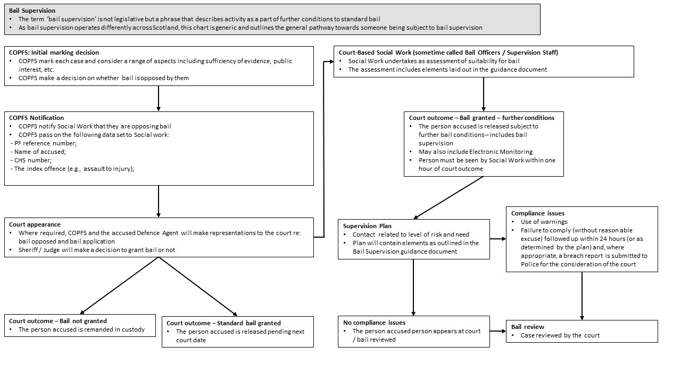  Key Principles  Bail Supervision should be underpinned by the following key concepts:  - Bail supervision should be regarded as an integral part of court social work services;  - Bail supervision does not supplant standard bail but is bail with additional conditions that provides an option targeting those whose application for bail might otherwise have been unsuccessful;  - The Procurator Fiscal will identify where bail is to be opposed or, where bail is not opposed, ask the court to grant bail with any additional conditions that may be considered necessary, proportionate and in the public interest,  - The roles of the respective organisations involved in the operation of bail supervision need to be clearly defined;  - The legitimate expectations of courts need to be clearly understood by all parties;  - Operational arrangements should not unduly delay court processes and procedures;  - Criminal Justice Social Work teams should provide Sheriffs and the Procurator Fiscal with regular updates on the services that have been made available in their area. Services should be developed according to local need and should include services commissioned from Third Sector organisations where appropriate.    Your data collection throughout this template should help to answer questions about whether or not the existing delivery of Bail Support and Supervision is an effective provision locally. It is therefore important to have these questions in mind when collecting information about your demographics, needs and services. If you want to explicitly agree these questions with partners before completing this template there is further guidance on how to do this within the Strategic Needs and Strengths Assessment (SNSA) guidance under the headings “Data Collection Plan”. Any local evaluation of Bail Support and Supervision will be particularly helpful.  Key Roles  COPFS , Defence Agents, Court Social Work (Bail Officer), Local authority (Social Work) and Partner Agencies(Including third sector) are the main partners involved in the Bail Supervision process.  The role of COPFS at the first stage of the process is to notify court social work of the cases they have marked where they are opposing bail.  Who is the local contact for the Procurator Fiscal? Some important questions to ask them might be:  - How are they assured that key information is accurate and robust?  - How are COPFS advised on developments and progress in Bail supervision to remain confident in its use?  Defence Agents can, via consent from their client, ask Social Work for information.  As it is unlikely CJP’s will have direct contact for Defence Agents, it may be possible to have some dialogue on this with the local Bar Association. Should this prove challenging, or outside of available time constraints, Social Work may be able to offer some guidance on whether this is routinely utilised.  Some important questions to ask them might be:  - What information do Defence Agents receive from Social Work regarding locally available Bail Supervision Services?  - Are Defence Agents aware of how to contact Social Work and how to make a specific request for assessment for Bail Supervision in Court?  The Court Social Worker (Bail officer / Bail Supervision Staff) undertakes an assessment of suitability for bail based on the list outlined in page 17 of the Bail Supervision guidance  Who oversees Bail Supervision locally? Is this person based within the Court or Local Authority? Some important questions to ask them might be:  - What information do Social Work use or receive in order to make a suitability assessment, and when is this received?, e.g. currently, from COPFS, Social Work get the following: PF reference number; Name of accused; CHS number; The index offence (e.g., assault to injury) and a statement that they intend to oppose bail  - What information is communicated to the individual and other partners (primarily Local Authority regarding the decision and how (prior to commencement) ?  The Role of the Local Authority (Social Work) is to maintain the correct level of contact (as noted on page 20 of the guidance). The content of the supervision will be as per the agreed action plan. This should include a package of supervision, and assistance with how to access appropriate support services, including accommodation. This is aimed at providing the opportunity for Bail to an individual who would otherwise be at risk of remand. Information to improve access to appropriate support services related to bail supervision will be dependent on the services provided in local authority areas by community justice partners, including third sector providers.  It is also the role of Local Authority (Social Work) to monitor an individual’s compliance with the condition of Bail Supervision. Where an individual demonstrates actions and behaviour which would fail in their compliance with the plan, Social Work have a duty to address this with an individual through exploration of the reasons for that and potentially, the issuing of warnings and/or reporting the breach to Police at the earliest opportunity.  Who, within the Local Authority (Social Work), oversees Bail Supervision? Some important questions to ask them might be:  - What information is included within the action plan for an individual and how is this communicated to key stakeholders such as partners and the individual? How are Bail Support and Supervision intervention programmes agreed and designed, and are any other partners and / or the individual involved?  - Does engagement with services generally start immediately?  - How is an individual supported to comply with the Bail Supervision requirement placed upon them, and in the event of potential breach, how is this explored and reported where necessary?  - How are universal services available locally utilised as part of Bail Supervision, and do referrals occur during this period to support sustainable life choices?  Include a summary of any identified local strengths or issues within this section.
Demographic profile | There are nationally published data tables available which contain data relating to Bail Supervision. These include:  Requests from Court for bail information  Bail supervision cases commenced  Bail supervision individuals  Your COPFS and Social Work partners may be able to provide a further breakdown of data. This will be subject to local processes and protocols around data requests and may take some time to arrange so it is important to factor that in to your planning. Examples of data that might be available locally are noted in page 29 of the guidance.  When considering the potential for Bail Support and Supervision locally, it is important to analyse data on the population remanded in custody from your local authority area. This will provide insight into what capacity may be required should Bail Support and Supervision be more fully utilised as an alternative to remand, and the needs of those who may utilise the service.  There are nationally published data tables on SPS Prison Population numbers, broken down by, Gender, Age, and Status.  Untried  Convicted awaiting sentence  Sentenced  In addition to the above, SPS provide local authority partnerships with monthly reports on the prison population, which includes data on remand, broken down by:  Gender  Age  Liberation  Admission  Other data which may support a broader analysis of the potential for Bail Support and Supervision within the local area is Police custody data. This may give information on crime type, age, gender, ethnicity, local and needs experienced by both charged and held in this manner. It may also indicate where assessment could be targeted and how to get key messages across to services and individuals.  Include a summary of any identified local strengths or issues within this section.  Use the information above to extract data relevant to your local area. Provide a narrative as well as a visual description of the data. This turns data description into data analysis. Provide details of any trends in relation to the referral data.  Using Scotland wide data, the following is an example of how data might be represented:  Another example of a visual description of data is as follows:  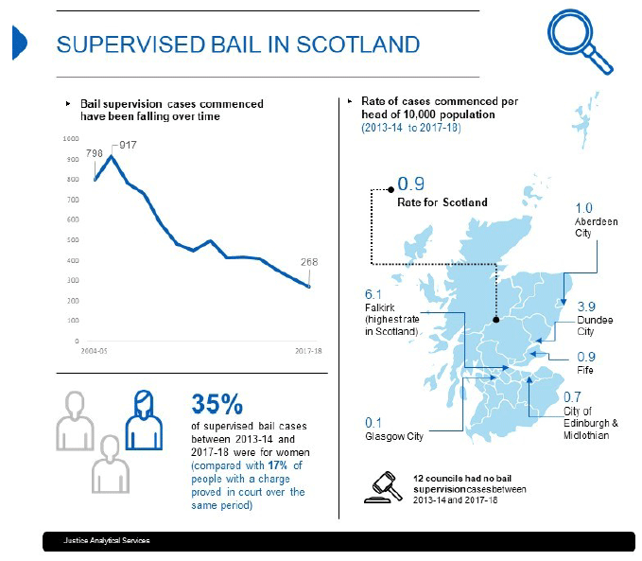
Needs profile | At a national level, data is not collated on referrals made for support to address needs within Bail Support and Supervision. Data is also not collated on reasons/requests for remand in custody, over a decision/request to grant Bail (COPFS or Judiciary). It is likely that this will be held by Justice Social Work Services at a local level, and this should be utilised to give an indication of the needs experienced by those already receiving this service.  In order to analyse what might be needed by the service if this was to be more widely utilised to reduce remand in custody within the area, there are a number of local data sources to consider which may indicate needs to be addressed at this earlier stage. These are:  Police charge data: crime type, age, gender, link to substance misuse.  Police custody data: crime type, age, gender, identified substance misuse or mental health need, housing status.  Justice Social Work: LS/CMI data (needs profile)  Justice Social Work: Exit Questionnaire data on needs identified and whether addressed.  Justice Social Work: Any available outcome measurement capture tool (for example, Outcome Star).  Use the information above, and any further relevant information to extract and consider information relevant to informing the picture of needs in your local area. Providing a narrative against any figures or visual representation of data will support the transition from data description to data analysis. Provide details of any trends apparent from that analysis. Include a summary of any identified strengths and weaknesses from this assessment.
Services profile | Establish who delivers Bail support & supervision locally. Who commissions and funds the service and who delivers it? Have any recent evaluations of services been completed? Work with your local service provider(s) to establish what services are relevant in onward referral locally in terms of needs identified (for example housing, financial inclusion and mental health). Are there any established fast-track pathways into treatment or support services? How are these configured to avoid breach of bail?  You may consider the development of a questionnaire to inform your service map locally. This could include information about:  - Organisation Details - Name, composition, nature of engagement with CJP  - Service Details – Name, purpose, eligibility criteria, engagement period, whether voluntary or statutory, needs addressed, referral pathway  - Service Delivery – Stage(s) of the justice process, current delivery, potential delivery  - Demographic Data – Number of people, gender, age range, employment status  - Outcomes Data –Link to national community justice outcomes, link to local CJOIP outcomes, outcomes data held, process for recording outcome data  - Funding – Funder(s), funding cycle, tendering process, funding trends, decommissioned services.  Once you have information about services it may be helpful to use an index to further understand the provision locally. For example, the following table shows how services involved in the delivery of Bail Support and Supervision might be mapped against the needs that they aim to address:  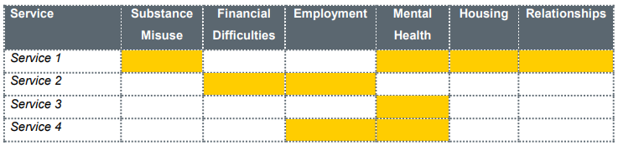  This will be particularly helpful to establish how the services compare / map against the needs identified. For example, are those who are remanded In custody or give bail routinely experiencing issues with substance misuse, and are services in place to address this as part of Bail support and supervision? Include a summary of any identified local strengths or issues within this section.
Horizon Scanning | Horizon scanning techniques will be particularly helpful and are explained in more detail in the SNSA guidance. Horizon scanning is an overarching term for identifying and then analysing future impacts on the topic or theme for a SNSA, to allow policy makers to consider how these effect delivery and practice. A properly executed horizon scanning exercise can be hugely beneficial to a proactive partnership to enable it to maximise opportunities for change or mitigate risks, rather than merely react.  As provided within the SNSA guidance, horizon scanning can be achieved effectively by considering issues under headings covered by the PESTELO acronym. It is also helpful to conduct a SWOT analysis as part of a horizon scan to support analysis of how issues will affect your partnership and what might need to be actioned against these.  An example of an emerging issue to consider as part of a horizon scanning exercise is the COVID-19 pandemic. This crosscuts all themes included in PESTELO, as this will have a range of implications for local partnerships in the delivery of Bail Support & Supervision from a national perspective. For example:  Since June 2020 the prison population in Scotland began to rise and did so for 16 consecutive weeks. In particular, the remand population increased to reflect 28% of the total population at its peak. As a result, there is a need to reduce the remand population, and nationally Bail Support and Supervision has been highlighted as a way to achieve this. This has resulted in a review of the National Guidance on Bail Supervision and briefings to the judiciary on availability of Bail Support and Supervision nationally.  For consideration: How aware are the local judiciary of Bail Support and Supervision Services? How might an increase in referrals for Bail Support and Supervision directed nationally, impact on local capacity across community justice delivery? Based on the needs of those in the system, which other agencies might be affected by this? What actions might need to be put in place to consider this?  Work with all relevant partners in a workshop capacity to complete a horizon scan and related SWOT analysis against Bail Support and Supervision. Where this is not possible, completed matrices should be shared with partners for their comment and inclusion of specific impacts. The impact of the pandemic to your partners should also be understood on Bail Support and Supervision as part of this analysis. Priority themes emerging from a horizon scan can be either included throughout a SNSA or attached as an appendix to that. These will need considered when forming outcomes and action as part of the subsequent plan where appropriate.  Include a summary of any identified local strengths or issues within this section.
Other information |   It is helpful here for CJPs to consider how outcomes for people presenting within Bail Support and Supervision are being achieved within other strategic landscapes. This might include the Local Outcome Improvement Plan (LOIP) for the area, the health and social care (Integration Joint Board) strategic plans, local health improvement plans and alcohol and drug partnership activity. Exploring outcomes may identify common actions which can be shares and developed in partnership.  Include a summary of all additional information within this section.
Data analysis and inference development | The following are examples of inferences that might be drawn from Scotland wide data and information:  - Between 2017-18 and 2018-19, the number of requests for court information, cases commencing and individuals receiving Bail Support & Supervision increased. This is against a trend in reducing numbers year on year since 2014-15. Such an increase may indicate improved awareness of the service.  - This is the first year since 2014-15 that total cases commenced reflected over 5% of the total requests for Bail information.  - The rising remand population in Scotland will require mitigation through the greater use of alternatives to custody, like Bail Support and Supervision. This will increase demand for the service and potentially present a greater level of need to be addressed and risk to be managed within those who receive the service.  By collating all of the information in this template, what can you say (either conclusively or hypothetically) about Bail Support & Supervision in your local area? It is important to consider all conclusions based on your assessment of evidence. Where you identify good practice consider how this can be scaled up, replicated or shared. Where you can only hypothesise shows where there are gaps in your evidence picture which will require to be addressed with more information. Filling those gaps can be improvement activity in itself.  What are the needs that people face and their potential causes, and what action can be taken to address these? Where are the strengths in service delivery and where are the gaps or opportunities for improvement?  Your Police and Social Work partners may be able to provide a further breakdown of locally-specific data. This might provide further insight into trends in crime committed and the needs that have been identified in relation to Bail Support & Supervision. This will give the opportunity to explore potential causes and consider whether interventions offered as part of Bail Support & Supervision can effectively address both offending and its causal factors.  Considerations: Are interventions available as part of Bail Support & Supervision aligned effectively to the offence type and needs and causal factors identified? What does the LOIP set out in response to deprivation in the areas identified? Can Bail Support & Supervision from prosecution activity link to existing provision to address deprivation in these areas, where this is not already achieved? How might capacity within the services working across Bail Support and Supervision be impacted by national changes?
Recommendations and priority setting |   You should now have a range of quantitative and qualitative data and information available to you about the provision of Bail Support & Supervision in your local area. Using the data analysis and inference development section as a basis, list the items that you have identified as strengths alongside those that require improvement (referred to as improvement activity). It is important to note that gaps in information you have identified may also form an action to be addressed.  Improvement activity should now by prioritised. This doesn’t mean that improvement activity that doesn’t reach the top of the list will never get done; it might get done at a later time, it might be that it cannot be completed until something else is done or it might mean that resource needs to be freed up at a later date. The CJP can use this SNSA template, once complete, as an audit trail of decision making and to ensure that improvement activity that isn’t prioritised doesn’t get forgotten.  An impact versus effort matrix is a simple tool that can help to generate conversation and aid partners in their decisions making regarding prioritisation.  High Impact High Effort – “Major Projects”  High Impact Low Effort – “Easy Wins”  High  Impact  High Effort Low Impact – “Thankless Tasks”  Low Impact Low Effort – “Low Hanging Fruit”  Low  High  Effort  Low  CJPs can set the axes on the above matrix according to what will be the most helpful to make an informed choice regarding prioritisation. As well as impact and effort, as shown in the example, CJPs might consider changing the axes to importance versus urgency, cost versus benefit or risk versus reward.  Placing the identified improvement activity on the matrix is best done collaboratively as a group activity as it will probably take some conversation and debate before reaching an agreed position for each.  Developing a scoring criteria is another method that can be helpful in prioritising activity. You might ask partners to assign a score across a range of criteria. For example:  For this table, you could set the following priority ratings:  It is important to remember that this template is one of a number that will make up a whole SNSA for the local area. Therefore, this technique should also be considered to prioritise all improvement activity being considered for inclusion in the area’s CJOIP.
  Improvement Activity | Critical to Meeting Standards | Strategic Value | Ease | Benefit to the Individual | Cost | Resource Impact | Overall Priority
  Imp Activity 1 | 4 | 1 | 3 | 3 | 5 | 2 | 3
  Imp Activity 2 | 5 | 2 | 4 | 4 | 4 | 5 | 4
  Imp Activity 3 | 1 | 1 | 5 | 1 | 3 | 4 | 2.5
  Critical to meeting standards? | Is the improvement activity crucial to ensure effective Bail Support and Supervision provision? | 1 = Critical | 5 = Not critical
  Strategic Value? | Is the improvement activity important to your overall strategy? | 1 = Highly important | 5 = Not important
  Ease? | Will the improvement activity be fairly east to complete? | 1 = Very easy | 5 = Very difficult
  Benefit to the individual? | Will the improvement activity likely yield significant benefit to the individual? | 1 = Highly likely | 5 = Not likely
  Cost? | Will the improvement activity likely cost a lot? | 1 = Low cost | 5 = High cost
  Resource impact? | Will the improvement activity have a great impact on CJP resource? | 1 = Low impact | 5 = High impact
  Overall priority: | Average score of all five criteria
  Note: In this example, the lower the score the higher the improvement activity’s priority
Developing outcome improvement actions | Once the CJP have decided on the priority improvement activity for Bail Support and Supervision in the area, consideration needs to be given as to how this will be expressed within the CJOIP.  A good way to approach this is to write an objective which describes what the CJP are trying to achieve. Use the SMART acronym to define how the CJP are going to know if the improvement activity is successful:  Specific – outline in a clear statement precisely what is required  Measurable – include a measure that will enable the CJP to monitor progress and to know when the objective has been achieved  Achievable – ensure there is commitment and capacity to carry out the necessary activity  Realistic – ensure there are no factors which would make the achievement of the objective impossible or unlikely  Time-bound – agree the date by which the activity must be completed  The CJP should now be able to answer the following questions about Bail Support and Supervision in the local area:  - What recommendations can you make to improve Bail Support and Supervision in the local area?  - Who do the recommendation impact on in terms of action and delivery?  - What is the intended impact of the actions that follow a recommendation?  - What are the priority areas for action arising from the SNSA for Bail Support and Supervision in the area?



First published December 2020

Community Justice Scotland, R1 Spur Saughton House, Edinburgh, EH11 3DX

Tel: 0300 244 8420

www.communityjustice.scot

